## Kinesis Streams

* Producers -> Streams (with Shards) -> Consumers
* To process or analyse streaming big data
  + Social media, news feeds, logs

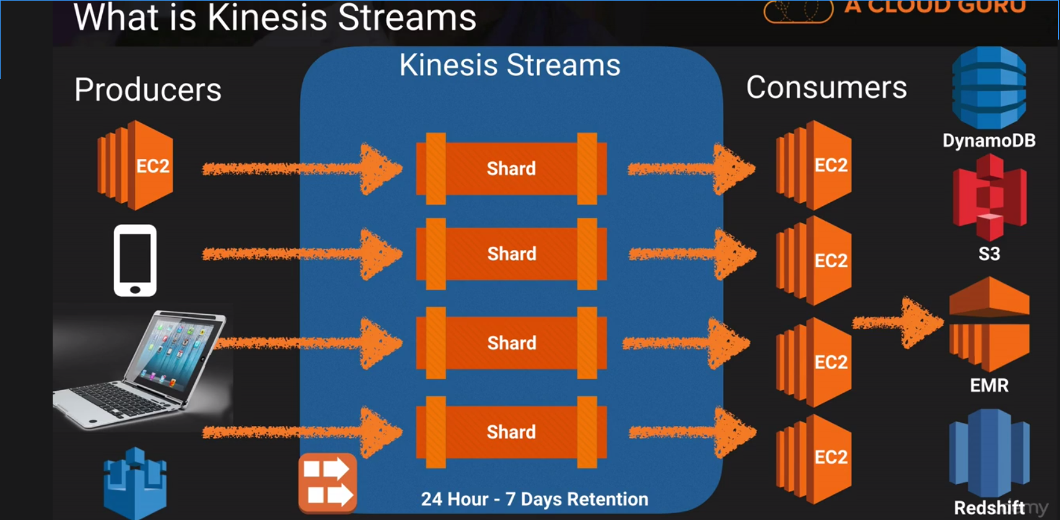

## Kinesis Firehose

* Producers -> Firehose -> S3
* With optional Analytics
* Easiest way to load streaming data in AWS

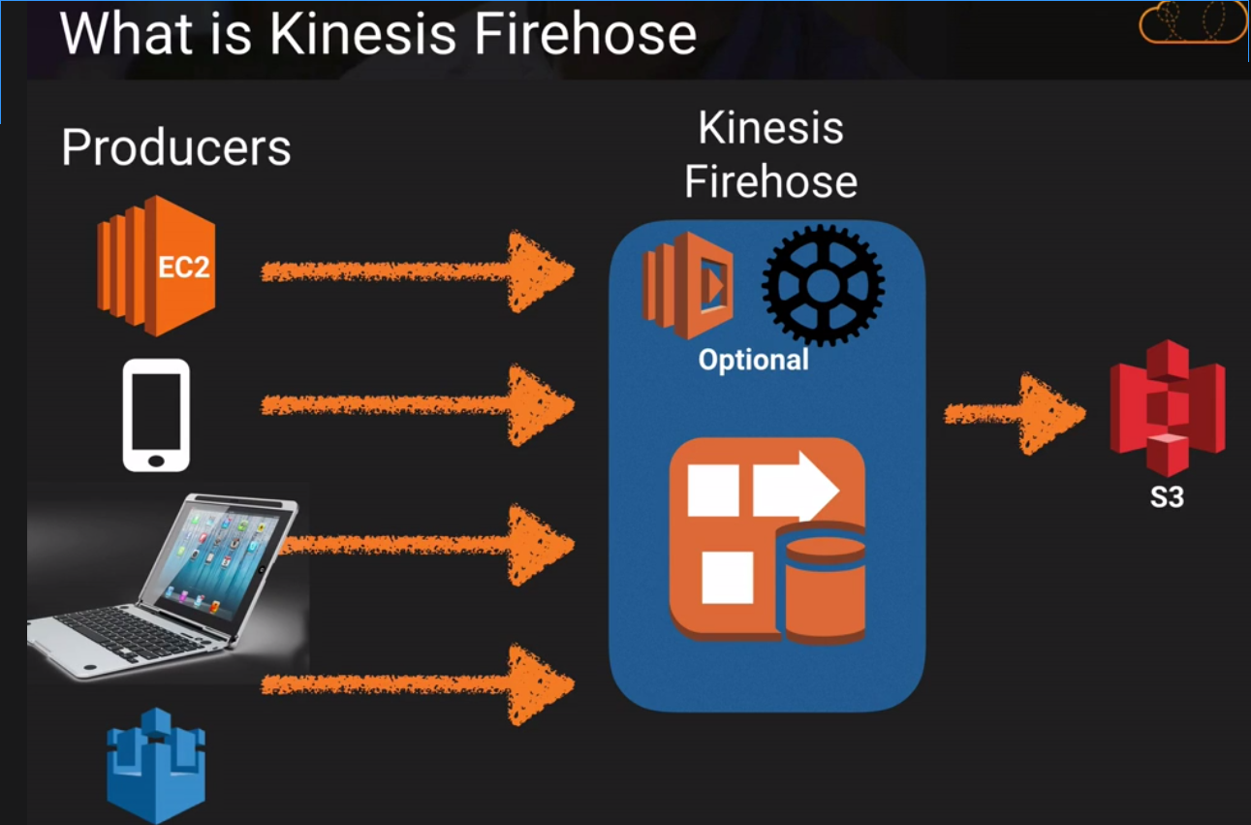

## Kinesis Analytics

* Producers -> Kinesis Analytics -> S3 / RedShift / Elastic Search Cluster
* process streaming data in real time with standard SQL

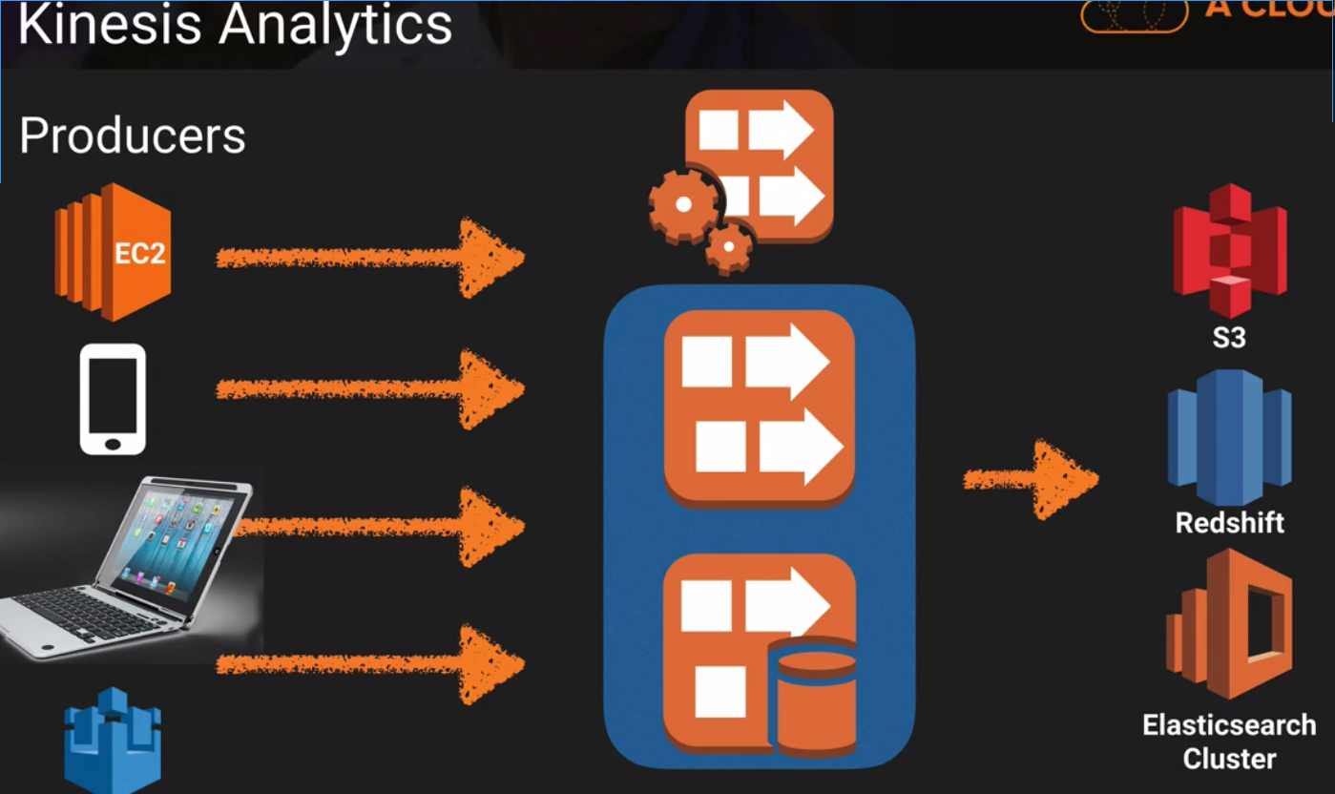

* Use Amazon Kinesis Streams to collect and process large streams of data records in real time.
* Use Amazon Kinesis Firehose to deliver real-time streaming data to destinations such as Amazon S3 and Amazon Redshift.
* Use Amazon Kinesis Analytics to process and analyze streaming data with standard SQL.